**Assignment 4**

**Presented by: Qi (daniel) ZHENG G44426724, Sizhe WU G26890251, Ruibo WANG G24256043, Yinyu LIN G48092483, Xinyue ZHAO G27620695**

**Part 1 (a)**

**Figure 1.1 Time series plot of growth of GNP**

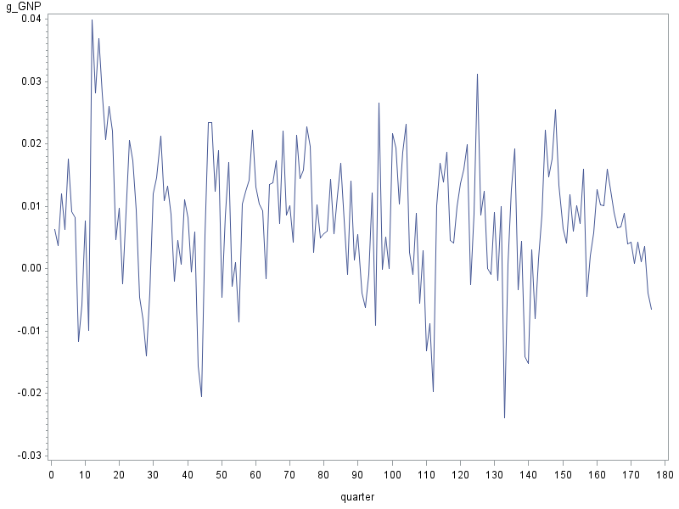

**Table 1.2. Output of ARIMA**

**(a). Summary output**

| **Name of Variable = g_GNP** | |
| --- | --- |
| **Mean of Working Series** | 0.007741 |
| **Standard Deviation** | 0.010697 |
| **Number of Observations** | 176 |

**(b). Autocorrelation**

| **Lag** | **Covariance** | **Correlation** | -1 9 8 7 6 5 4 3 2 1 0 1 2 3 4 5 6 7 8 9 1 | **Std Error** |
| --- | --- | --- | --- | --- |
| **0** | 0.00011443 | 1.00000 | |                    |********************| | 0 |
| **1** | 0.00004312 | 0.37687 | |                 .  |********            | | 0.075378 |
| **2** | 0.00002905 | 0.25391 | |                 .  |*****               | | 0.085416 |
| **3** | 1.4332E-6 | 0.01253 | |                .   |   .                | | 0.089602 |
| **4** | -9.8318E-6 | -.08592 | |                . **|   .                | | 0.089611 |
| **5** | -0.0000123 | -.10706 | |                . **|   .                | | 0.090078 |
| **6** | -6.5788E-6 | -.05749 | |                .  *|   .                | | 0.090798 |
| **7** | -2.0849E-6 | -.01822 | |                .   |   .                | | 0.091005 |
| **8** | -8.8383E-6 | -.07724 | |                . **|   .                | | 0.091026 |
| **9** | -8.0315E-6 | -.07019 | |                .  *|   .                | | 0.091397 |
| **10** | 1.19116E-6 | 0.01041 | |                .   |   .                | | 0.091703 |
| **11** | -2.6307E-6 | -.02299 | |                .   |   .                | | 0.091710 |
| **12** | -0.0000111 | -.09673 | |                . **|   .                | | 0.091743 |
| **13** | -0.0000116 | -.10106 | |                . **|   .                | | 0.092320 |
| **14** | -0.0000131 | -.11454 | |                . **|   .                | | 0.092947 |
| **15** | -8.5437E-6 | -.07467 | |                .  *|   .                | | 0.093745 |
| **16** | 3.3379E-6 | 0.02917 | |                .   |*  .                | | 0.094083 |
| **17** | 7.06801E-6 | 0.06177 | |                .   |*  .                | | 0.094134 |
| **18** | 0.00001049 | 0.09163 | |                .   |** .                | | 0.094364 |
| **19** | 3.93535E-6 | 0.03439 | |                .   |*  .                | | 0.094868 |
| **20** | 2.81195E-6 | 0.02457 | |                .   |   .                | | 0.094939 |
| **21** | -4.4305E-6 | -.03872 | |                .  *|   .                | | 0.094975 |
| **22** | -2.4663E-6 | -.02155 | |                .   |   .                | | 0.095065 |
| **23** | -0.0000101 | -.08830 | |                . **|   .                | | 0.095093 |
| **24** | -8.3708E-6 | -.07315 | |                .  *|   .                | | 0.095557 |

The time series (Figure 1.1) is behaving in a stochastic pattern, and drafting both upward and downward with no sign of exhibiting any trend, which is expected if it is a stationary time series. According to the autocorrelations table (Table 2.1(b)), only the first three autocorrelations (lag 0, lag1, and lag 2) are significant, but the value of autocorrelation from lag 1 to lag 24 decays more quickly than the benchmark where Φ1=0.9. Therefore, we could conclude that the series looks stationary.

**Part 1 (b):**

**Table 1.2. Output of ARIMA**

**(a). Autocorrelations**

| **Lag** | **Covariance** | **Correlation** | -1 9 8 7 6 5 4 3 2 1 0 1 2 3 4 5 6 7 8 9 1 | **Std Error** |
| --- | --- | --- | --- | --- |
| **0** | 0.00011443 | 1.00000 | |                    |********************| | 0 |
| **1** | 0.00004312 | 0.37687 | |                 .  |********            | | 0.075378 |
| **2** | 0.00002905 | 0.25391 | |                 .  |*****               | | 0.085416 |
| **3** | 1.4332E-6 | 0.01253 | |                .   |   .                | | 0.089602 |
| **4** | -9.8318E-6 | -.08592 | |                . **|   .                | | 0.089611 |
| **5** | -0.0000123 | -.10706 | |                . **|   .                | | 0.090078 |
| **6** | -6.5788E-6 | -.05749 | |                .  *|   .                | | 0.090798 |
|  |  |  |  |  |

**(b). Partial autocorrelation**

| **Lag** | **Correlation** | -1 9 8 7 6 5 4 3 2 1 0 1 2 3 4 5 6 7 8 9 1 |
| --- | --- | --- |
| **1** | 0.37687 | |                 .  |********            | |
| **2** | 0.13040 | |                 .  |***                 | |
| **3** | -0.14209 | |                 ***|  .                 | |
| **4** | -0.09880 | |                 .**|  .                 | |
| **5** | -0.01995 | |                 .  |  .                 | |
| **6** | 0.03253 | |                 .  |* .                 | |

According to the Table 2.1(b), partial autocorrelations of Lag 2 and Lag 3 seems significant; however, from Table 2.1(a), autocorrelation of Lag 2 is significant, and the autocorrelation of Lag 3 is not significant. Therefore, we were in need to conduct an autoregression process to the second order urgently to determine the significance.

**Table 2.2 Output of AR(2)**

| **Conditional Least Squares Estimation AR (2)** | | | | | |
| --- | --- | --- | --- | --- | --- |
| Parameter | Estimate | Standard Error | t Value | Approx Pr > |t| | Lag |
| **MU** | 0.0076333 | 0.0013830 | 5.52 | <.0001 | 0 |
| **AR1,1** | 0.33072 | 0.07556 | 4.38 | <.0001 | 1 |
| **AR1,2** | 0.13440 | 0.07583 | 1.77 | 0.0781 | 2 |

Estimated AR (2) process: $$Y_{t}=0.1344Y_{t-2}+0.33072Y_{t-1}+0.0076333$$

By observing the conditional least squares estimation AR(2), we obtained the P-value of the first lag term (AR1,1) to be < 0.05, and the second lag term (AR1,2) to be 0.0781 > 0.05. As a result, we concluded that the coefficient at the lag of 2 (AR 1,2) is not statistically significant, while coefficient of AR1,1 is significant. However, second-order autoregression model cannot be reduced to a first-order one, and we must conduct a first-order autoregressive process to generate the appropriate model here.

**Table 2.3 Output of AR(1)**

| **Conditional Least Squares Estimation AR(1)** | | | | | |
| --- | --- | --- | --- | --- | --- |
| **Parameter** | **Estimate** | **Standard Error** | **t Value** | **Approx Pr > |t|** | **Lag** |
| **MU** | 0.0076840 | 0.0012065 | 6.37 | <.0001 | 0 |
| **AR1,1** | 0.38074 | 0.07052 | 5.40 | <.0001 | 1 |

Estimated AR(1) process:

$Y_{t}=0.38074Y_{t-1}+0.0076840$

According to Table 2.3, the P-value of the first lag term (AR1,1) is < 0.0001, and thus < 0.05, and we could conclude that the coefficient AR1,1 is statistically significant. As a result, the first-order autoregression model, $Y_{t}=0.38074Y_{t-1}+0.0076840$, turned out to be the proper model for our purpose here.

**Part 1 C:**

| **Table 3.1 Autocorrelation check of residuals** | | | | | | | | | |
| --- | --- | --- | --- | --- | --- | --- | --- | --- | --- |
| **To Lag** | **Chi-Square** | **DF** | **Pr > ChiSq** | **Autocorrelations** | | | | | |
| **6** | 8.36 | 5 | **0.1372** | -0.051 | 0.170 | -0.057 | -0.071 | -0.079 | -0.019 |
| **12** | 11.76 | 11 | **0.3822** | 0.036 | -0.063 | -0.064 | 0.056 | 0.008 | -0.074 |
| **18** | 15.79 | 17 | **0.5389** | -0.042 | -0.077 | -0.062 | 0.044 | 0.027 | 0.080 |
| **24** | 18.55 | 23 | **0.7268** | -0.005 | 0.040 | -0.056 | 0.028 | -0.077 | -0.046 |

Table 3.1 is the autocorrelation table of residuals where χ2-testing results are shown. For χ2-testing, there are null hypothesis H0: residual series {εt} is unautocorrelated to the indicated lag, and alternative hypothesis Ha: {εt} is autocorrelated to at least one lag smaller than the indicated lag. With all P-values greater than 0.05, we retained all of null hypotheses, and must conclude statistically that all autocorrelations up to a lag of 24 are 0. Since autocorrelations die out with lag increasing, all autocorrelation can then be seen as equal to 0. Because the residual term is zero-mean and homoscedastic, χ2-testing in our case essentially tests for white noise. Therefore, the residual term is a white noise series on a statistical basis.

**Part 2:**

(a) Estimate the constant term C, coefficient $ϕ_{1}$ and write down the estimated AR(1) model.

Solution:

At lag=1, $ϕ_{1}=r_{1}=0.709$

For estimation of unconditional mean of Yt:

Solve for constant: $C=μ×\left(1-ϕ_{1}\right)=40.268×\left(1-0.709\right)=11.718$

Model AR(1): $Y_{t}=0.709Y_{t-1}+11.718$

(b) Estimate the autocorrelations at lag 2 and 3, and the partial autocorrelation of lag 1.

Solution:

For AR(1) process: $r_{k}=ϕ_{1}r_{k-1}=ϕ_{1}^{k}$

Therefore,

$$r_{2}={ϕ_{1}}^{2}={0.709}^{2}=0.50268$$

$$r_{3}={ϕ_{1}}^{3}={0.709}^{3}=0.35640$$

Also, for AR(1) process: $PACF\left(1\right)=ϕ_{1}=0.709$

That is, the autocorrelations at Lag 2 and Lag 3 are 0.50268 and 0.3564 respectively. And, according to the statistically induction, we know that the partial autocorrelation at lag 1 equals 0.709.

(c) Estimate the variance of the $ϵ_{t}$'s

Solution:

For estimation of unconditional variance of Yt: